University of Phoenix Material

1. Use the graph below to respond to (a) through (c):
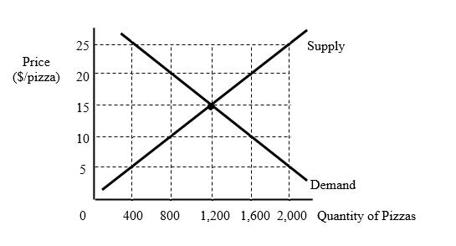
a) According to the law of demand and based on the graph, if the price per pizza falls from $20

to $15, what will happen to quantity demanded?

b) If government places a binding price ceiling of $10 in this market, will there be a shortage or a

surplus of pizza? How large?

c) If an increase in the cost of producing pizzas causes the supply curve to shift to the left, will

the equilibrium price per pizza rise or fall? What about the equilibrium quantity of pizzas?

2. If Frank can produce either 20 pizzas or 40 cheesecakes per day, the opportunity cost per

pizza is equal to how many cheesecakes?

If Fran can produce either 15 pizzas or 50 cheesecakes per day, which person (Frank or Fran) has

an absolute advantage making pizzas? What about cheesecakes?

